Teacher Information Pack
Self-guided School Visits

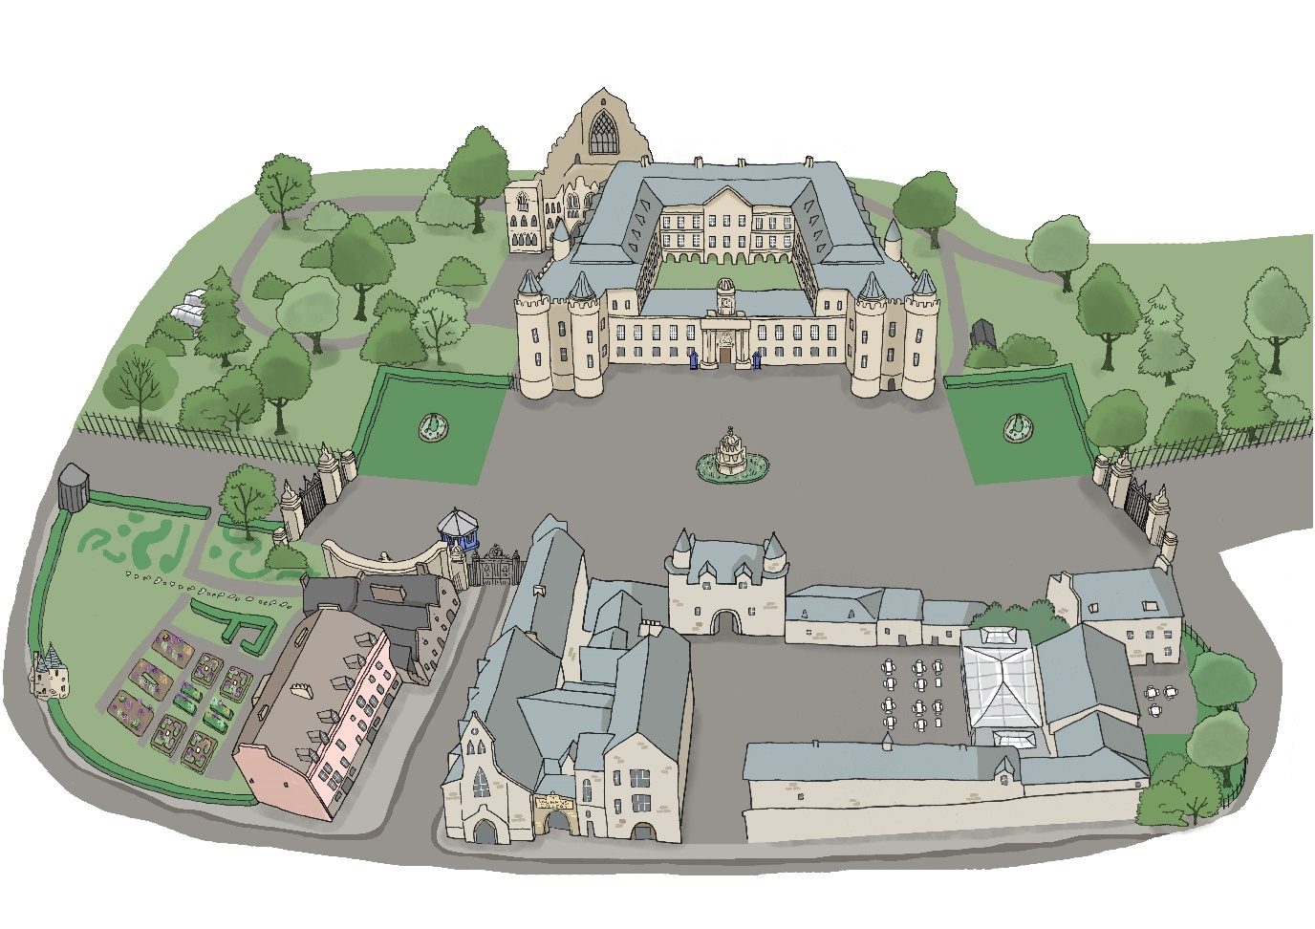

We are looking forward to welcoming you to the Palace of Holyroodhouse. This pack is designed to give you all the practical information you need to book and plan an enjoyable and safe visit.
Contents

Introduction
 | About the Palace of Holyroodhouse |  | 2
 | About Royal Collection Trust |  | 2
 | Our nursery and school programme |  | 2
 | Self-guided visit |  | 2
 | Self-guided visit prices |  | 2
Booking your visit
 | How to book your visit |  | 3
Before your visit
 | Health and safety |  | 4
 | Risk assessment |  | 4
 | Complimentary planning visit  Security |  | 4  4
 | Pre-visit resources |  | 5
 | Pre-visit SEND resources |  | 5
 | School gift bag |  | 5
Your visit
 | Getting to the Palace |  | 6
 | Arriving at the Palace |  | 6
 | Visiting the Palace – school visit guidelines |  | 6
 | Lunch |  | 7
After your visit
 | Post-visit resources |  | 8
 | Keep in touch and stay involved |  | 8
Appendix
Palace of Holyroodhouse map
No photography sign

Introduction
About the Palace of Holyroodhouse
The Palace of Holyroodhouse is His Majesty The King's official residence in Scotland. It has been the scene of important and dramatic events across the centuries involving Robert the Bruce, Mary, Queen of Scots, Bonnie Prince Charlie, Queen Victoria, and more.

About Royal Collection Trust
Royal Collection Trust looks after the Royal Collection, one of the most important art collections in the world and manages the public opening of the official residences of His Majesty The King. Through our work, from exhibitions and learning programmes to publications and retail products, we aim to ensure that the Royal Collection and Palaces are valued and enjoyed by everyone.

Our nursery and school programme
A visit to the Palace provides a memorable setting for learning and unique opportunities to meet Experiences and Outcomes of the Curriculum for Excellence. Our expert-led interactive sessions are suitable for pupils in nursery, primary and secondary school. To find out more about our nursery and school programme visit: https://www.rct.uk/discover/school-visits

Self-guided visit
As well as our programme of facilitated sessions we also offer self-guided visits of the Palace of Holyroodhouse. These visits are perfect for pupils from Second Level to Senior Phase requiring a general or focused visit. During self-guided visits pupils can collected a multimedia guide which has a tour suitable for children from 7-11 and a tour suitable for young adults and adults.
Self-guided prices
A self-guided visit of the Palace of Holyrood is £3 per pupil . Please be aware these prices are for pupils studying in the UK for pupils studying internationally bookings must be made through our Group Bookings Team.
One teacher or adult helper is admitted free of charge at the following ratios:
- P1 – P4 - 1 adult: 6 pupils
- P5 and above - 1 adult: 10 pupils
Additional teachers or adult helpers above this ratio to support SEND pupils are admitted free of charge.
Booking your visit

How to book your visit
To book your self-guided visit for pupils studying in the UK please consider the following and then contact the Learning Booking Team:
- Preferred date of visit and possible alternatives
- Preferred arrival time
- Numbers of children and supervising adults
Learning Bookings Team
Ticket Sales and Information Office
Buckingham Palace
London SW1A 1AA
T. (+44) (0)303 123 7323
F. (+44) (0)20 7930 9625
learning@rct.uk

Once you have made your booking you will receive a reservation letter. This reservation letter will confirm details of your booking including times and numbers of pupils and adults booked. Please read this carefully and if anything is incorrect contact the Learning Bookings Team. If your booking requires payment, the letter will confirm the date by which full payment must be received. All bookings are made subject to our terms and conditions. To see these please visit https://www.rct.uk/schools/teacher-information-documents
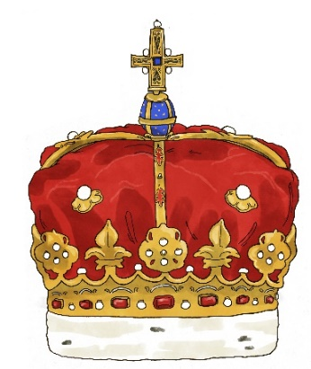
Before your visit

Health and safety
The Royal Household is committed to the principle of ensuring the health, safety and welfare of the general public within the royal residences. Under the guidance of our Fire, Health and Safety Branch, an established policy sets out staff and management responsibilities for all areas of activity and for the conduct of risk assessments.

The following statements summarise the main provisions of this policy:

- All areas at The Palace of Holyroodhouse, open for visitor admissions have been assessed both for compliance with current Health and Safety requirements and with the provisions of the Equality Act (2010).
- Regular inspections by operational, maintenance, and health and safety staff ensure that high levels of safety and visitor service are maintained. Cleaning and maintenance staff are available at all times during public opening hours, together with supervisory staff under the direction of a Duty Manager.
- Emergency procedures are published for all public areas, and staff undertake regular fire and evacuation training. All wardens are in radio contact.
- Trained first aid staff are available, supported by a permanently staffed fire surveillance team who are able to provide strong first aid cover
.
Risk assessments

The Royal Household has undertaken workplace risk assessments to cover all areas of operation, with a particular focus on visitor access and they are reviewed on a regular basis.

In order for you to carry out risk assessments specific to your class we offer complimentary planning visit tickets.

Security
On arrival your belongings will be subject to a bag check. Try to bring as little as possible with you as it will help you to get through this process more quickly. For full information, please visit Practical Information for visiting the Palace of Holyroodhouse (rct.uk) .

Complementary planning visit
Once you have booked your visit you are entitled to 2 complimentary tickets to the Palace so you can undertake a planning visit.. To book your complementary planning visit please contact the Learning Bookings Team.
Pre-visit resources
We have a range of resource available to help your class prepare for their visit. To explore these visit https://www.rct.uk/discover/school-resources

Pre-visit SEND resources
We also have resources to support SEND pupils including a visual story. To see these please visit https://www.rct.uk/visit/palace-of-holyroodhouse.

School gift bag
Royal Collection Trust has produced a giftbag for pupils. The giftbag contains mementos including a flag, postcard, notepad, pen, badge, pencil and eraser and can be pre-ordered for £3. For more information and to pre-order please visit https://www.rct.uk/schools/teacher-information-documents

Your visit
Getting to the Palace
By coach and bus | Bus number 35 stops near the Palace.  Limited free coach parking is available adjacent to the Palace on the North Approach. Alternative pay-and-display coach parking is available on nearby Regent Road.
By train | Edinburgh Waverley. The Palace is a 15 minute walk from the station. Visit National Rail Enquiries for times and fares.
By tram | The nearest tram stop is York Place. The Palace is a 20 minute walk from the station. Visit Edinburgh Trams for times and fares.

Arriving at the Palace
Please arrive to the Palace promptly for your self-guided visit at the time stated on your reservation letter.

Visiting the Palace

In order that everyone has a safe and enjoyable visit to the Palace, we ask all teachers and adults helpers to read the following guidelines:
School Visit Guidelines

- During the visit, teachers and adult helpers are responsible for pupils’ safety and behavior.
- Teachers and adult helpers must stay with the class at all times.
- Pupils are kindly asked not to run in the Palace. Teachers and adult helpers are asked to manage this.
- Pupils are kindly asked not to get too close or to touch paintings, objects or furniture. Teachers and adult helpers are asked to manage this.
- In the case of an emergency teachers, adult helpers and pupils are asked to follow the instructions of members of the Security Team and Visitor Services Team (Wardens).
- Photography is not permitted within the Palace but is permitted in the exterior areas. Please be aware that visitors to the Palace may try to take photographs of pupils. Wardens are vigilant and will speak to visitors if this occurs and ensure photographs are deleted. If you witness this happening before a Warden please speak to a Warden so they can speak to the visitor and ensure photographs are deleted.

Lunch
Unfortunately, we do not have an indoor space for self-guided school visits to have a packed lunch in. You are however more than welcome to use the Physic Garden for this. The Palace of Holyroodhouse also has a café where lunches can be purchased.

After your visit

Post-visit resources
We have a range of resource available to help your class continue their learning after their visit. To explore these visit https://www.rct.uk/discover/school-resources

Keep in touch and stay involved
We love to see and hear about your visit to the Palace and the learning it has inspired back in the classroom. If you would like to share any of this with us through social media please mention @RCT or use the hashtag #HolyroodPalace.
You can also stay in touch by subscribing to our school e-mail updates. Each term you will receive the latest news and details of upcoming school sessions, resources and teachers events. To sign up visit https://www.rct.uk/schools/sign-up-to-our-school-e-mail-updates

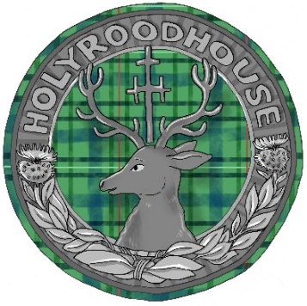

Palace of Holyroodhouse Map
1 | North Approach –  Coach Park
2 | Abbey Strand Centre
3 | Palace of Holyroodhouse
4 | Gift Shop
5 | Physic Garden
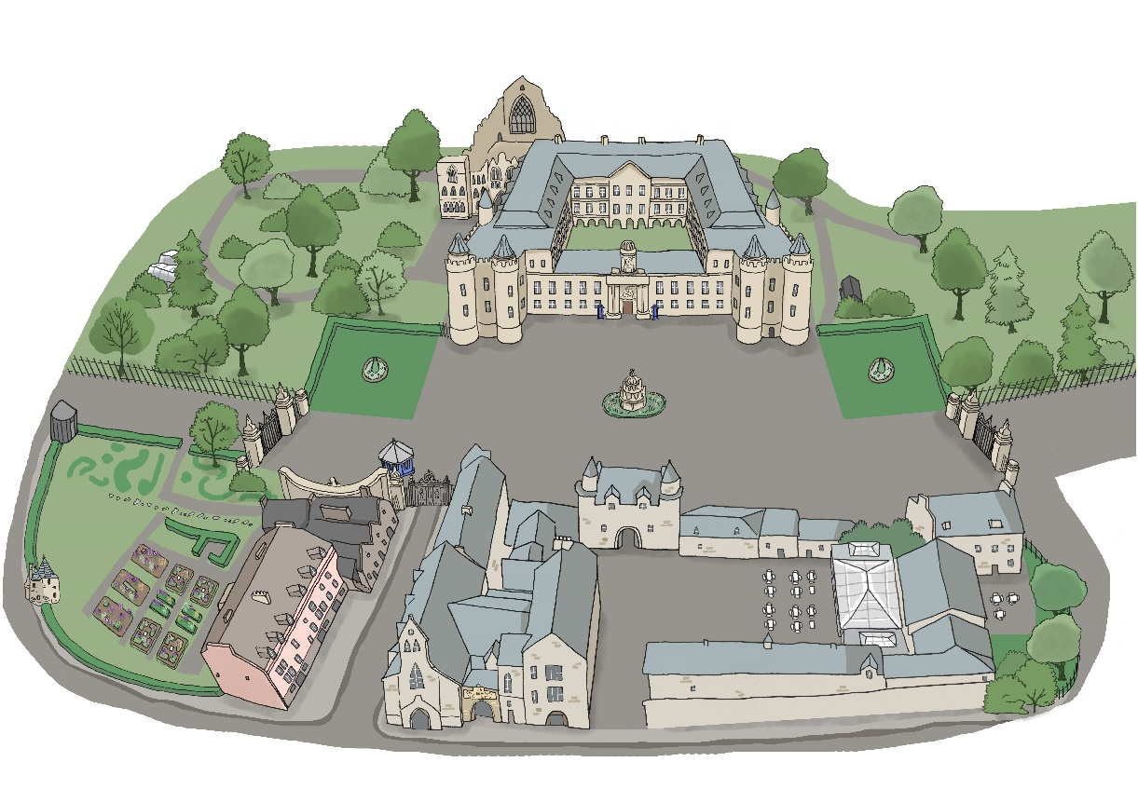
5
4
3
22
1
No photography

